Announcements:
1. Let’s give thanks to God for what He is doing in our ministry.
2. Casey will be collecting any information that may be missing from
you. Please respond to her requests in a timely manner.
3. As a starting ministry, we have many holes to fill. Please volunteer for
weekly positions, and let us know if there’s anything you’d like to do
for our group. The list of things you can do (though it is not limited
to that list) is located on our website.
4. Check the online calendar frequently to check which events are
occuring. Such as our group fasts, and other events.
Prayer Requests:
1. God’s continual guidance on the formation of our ministries
2. Through social activities, we’ll be able to meet new people, particularly
those that do not know Jesus, and that we’ll be able to win them over
with the Love of God.
3. Worship team and other aspects of our ministry. For God to send us
right workers that can fill the holes we have.
4. For us to honor God in all we do, and also be one in Christ
5. The formation of our ministry's vision and value statements
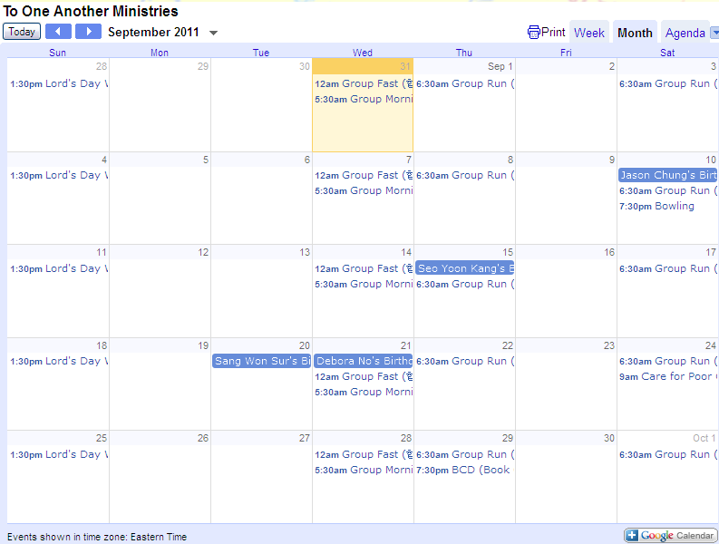
From our website (http://www.to1another.com)
Lord’s Day, September 11, 2011

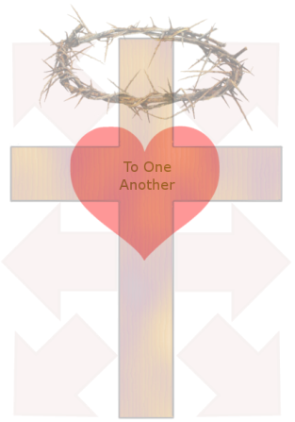

I am because We Are
우리이기 때문에 내가 존재 한다
yo soy porque nosotros somos

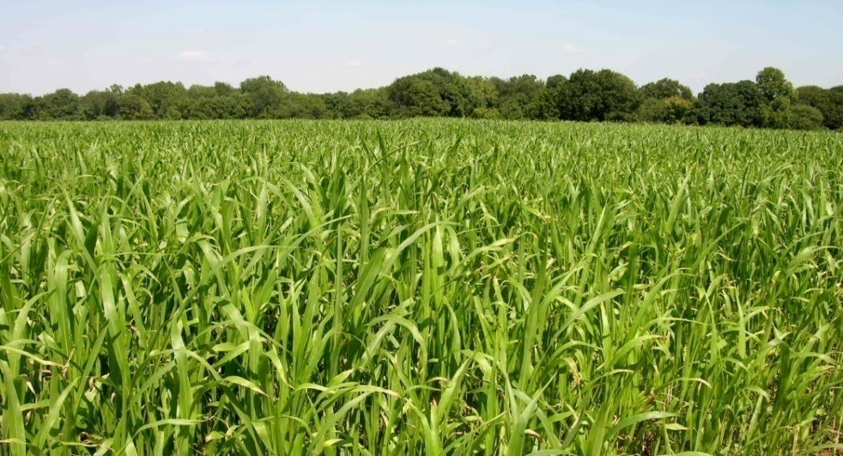

When we gather:
Let us worship (come before the transcendent God)
Let us pray (find significance through intimacy)
Let us come together (build community, love one another)

http://www.to1another.com
Order of Service (예배순서)
Entering into the Presence of the Lord
하나님 임재함으로 들어감
Praise and Worship Together Led by the Worship Team
찬양과 경배 찬양팀과 함께
Greet One Another
서로 인사
Declaration of the Mighty Word of God Col(골로새서) 1:16-29
하나님의 능력의 말씀 선포
What is the Good News?
복음이 무엇인가?
Encouragement for One Another
서로를 위한 격려의 말
Offering to the Lord
하나님께 드리는 헌금
Prayer for One Another
서로를 위한 기도
Sermon “People of Influence”
설교 영향을 미치는 사람들
Confession and Reflection
회개와 반성
Sending out/Benediction
발송 / 축도
Announcements
광고
Communion and Hang Out
친교와 교제

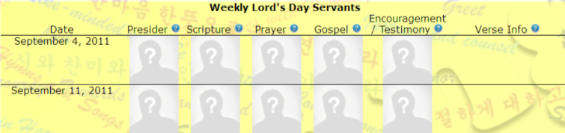
Volunteers desired: contact sister Seo Yoon Kang for info

If you say, “The LORD is my refuge,”
And you make the Most High your dwelling,
No harm will overtake you,
No disaster will come near your tent.
For he will command his angels concerning you
To guard you in all your ways;
They will lift you up in their hands,
So that you will not strike your foot against a stone.
You will tread on the lion and the cobra;
You will trample the great lion and the serpent.
“Because he loves me,” says the LORD, “I will rescue him;
I will protect him, for he acknowledges my name.
He will call on me, and I will answer him;
I will be with him in trouble,
I will deliver him and honor him.
With long life I will satisfy him
And show him my salvation.”

네가 여호와를 너의 보호자로 삼고
가장 높으신 분을 너의 피난처로 삼았으니
화가 너에게 미치지 못하고
재앙이 네 집에 가까이하지 못할 것이다.
그가 천사들에게 명령하여
네가 어디를 가든지 너를 지키게 하시리라.
천사들이 손으로 너를 받들어
네 발이 돌에 부딪히지 않게 할 것이다.
네가 사자와 독사를 짓밟아 누르리라.
하나님이 말씀하신다.
“그가 나를 사랑하므로 내가 그를 구출하리라.
그가 내 이름을 알고 있으니 내가 그를 보호하리라.
그가 나에게 부르짖을 때 내가 응답할 것이며
그가 어려움을 당할 때 내가 그와 함께하여
그를 구하고 그를 영화롭게 하리라.
내가 그를 장수하게 하여 만족을 누리게 하고
그에게 내 구원을 보이리라.”

-Psalm (시편) 91

